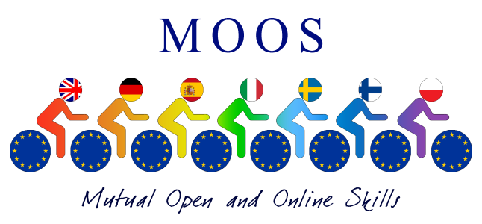
Project MOOS - Mutual Open and Online Skills
(Code: 2014-1-IT02-KA201-003651_1)

REPORT of 2nd Steering Meeting in Sweden.
19-20 May 2015
During the second Steering meeting all 14 delegates have agreed on the following points:
Agreed on:
Dates for England: 21-25 September 2015 (arrival 20 September and departure 26 September). Some students will stay in boarding house with English students, some in families. For staff there will be accommodation at school or at a nearby hotel.
Dates for Finland: 14-18 March 2016 (arrival 13 March and departure 19 March)
Dates for Spain: 3-7 May 2016 (arrival 2 May and departure 8 May)
Agenda in England: Staff/students develop a multilingual course. Staff evaluate the courses and make adjustments/changes.
Student credits: It is important that all participating students are given some kind of school credit for their participation in the project (i.e. taking the courses).
Students taking courses: Each school picks 5 students that are the test pilots and who will take the courses. You should engage more than these 5 in the courses but please note that only 5 are given the certificate in the end. The rest will have to be given some kind of diploma from the project.
Size/length of each course: 10 units, 30 minutes per lesson, 30 minutes for homework/exercises, each unit consists of two or more sections.
First unit/lessons: Are released on 1st September, 2015 and will stay open 3 weeks (up to the activity in England). All the courses will be published at the same time so that students can pick in which order to take them. We will keep that structure for all courses. The first lesson should be self-grading so that students get instant response on their performance.
Curriculum for each course: This Document should be ready by the 1st September 2015 when the first lesson is published. Should spring from the Common Curriculum, Teachers making the courses chooses the sections/skills that fit with one’s course , objectives and competences to be reached. The format of the Digital Common Curriculum was discussed and the Coordinator presented some slides on the different areas and skills to consider. Then all partners contributed in selecting the best indicators and competences to use in online lessons. A final document was produced by the Coordinator and sent to each partner .

Still to agree on:
1 or 2 courses: It will be difficult to develop two courses by September with high quality and it will be very difficult for students to take 14 courses instead of 7. But we will all try to handle with timing and the load of work and training - workshops.
At the end of the meeting it ws agreed that we all need to create 2 courses hopefully completed by September 2015 but they need to be both finished by April 2016. The committee also suggested to make shorter courses in order to discourage students from dropping out of courses or leaving them unfinished.
Another point discussed was
- -How to evaluate students in Spain in May 2016.
- If there were any rules/restrictions on the “europass” that the students will be given
- what to evaluate and how
Ely September 2015: Bring suggestions for dates for the next mobilities
The following Steering group date was decided for April 2016.
- If it was possible to make a MOOS certificate, but this was to be seen during the following training lab-workshops in Ely.

Suggestion for release dates of courses:
Unit | Open | Close | Length
1 | 1 September 2015 | 20 September 2015 | 3 weeks
2* | 28 September 2015 | 18 October 2015 | 3 weeks
3 | 19 October 2015 | 8 November 2015 | 3 weeks
4 | 9 November 2015 | 29 November 2015 | 3 weeks
5 | 30 November 2015 | 20 December 2015 | 3 weeks
6* | 4 January 2016 | 24 January 2016 | 3 weeks
7 | 25 January 2016 | 14 February 2016 | 3 weeks
8 | 15 February 2016 | 6 March 2016 | 3 weeks
9 | 7 March 2016 | 27 March 2016 | 3 weeks
10 | 28 March 2016 | 17 April 2016 | 3 weeks
* break for activity, Christmas

Doriana Papile
Transnational Coordinator

