(Code: 2014-1-IT02-KA201-003651_1)

Erasmus+ 3rd Steering Meeting from the 11th to 12th April, 2016 Poland
- Welcome to Poland
Music, introduction, presentation of Busko by local authorities and headmaster. Video presentation of MOOS Promo video.

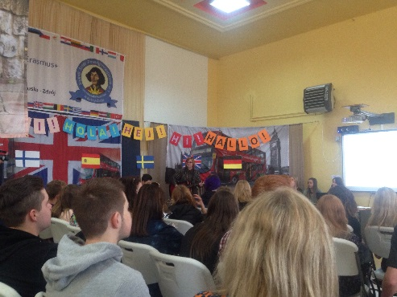

- Checkup of booking and tickets to Spain.
Travel on Monday the 2nd of May(or on Sunday the 1st of May), work 3rd-7th of May. It’s possible to travel home on Saturday earliest at 6 pm, otherwise travel home on the Sunday. You can go to Bilbao Madrid, Madrid is more convenient. Once tickets are bought let all the others know so that transfer can be arranged together and return ticket Madrid-Burgos.

- Discussion of activities in Spain for students.
Spanish Coordinater, Paz Cuevas, gave a short introduction of the activities to be held in Burgos
All activities are going to be digital. A new application called “thinglink” will be used rather than a paper version of the program carried out at school.

Activities will be arranged as icebreakers and uploaded via the app called “aurasma”. The application will give the students different missions that must be accomplished, documented via film and shared via application. Activates will be sent to the MOOS platform where teachers at school will be able to assess them.

The Spanish partners have also planned activities linked to the assessment of the finished courses, on what they have learned and on how the different competences will be shown and tested. This was followed by a discussion on how the knowledge and the competences students following MOOS courses can be assessed in a creative way that exemplifies what they have gained though out the different courses on the MOOS platform. Teachers have decided to set up a couple of questions that can steer the direction of the presentations. Students will give a short presentation of at least three courses.
Students from different countries must be mixed in different groups. Suggestions are paintings, videos, presentations and performances. Possibly the assessment from the students can be used for the dissemination of the project. Separate suggestions, instructions for assessment, see attached file.

- Dissemination of the project is discussed
The newsletter will be finished in Spain. Bring info and pictures from the courses. The information has to be attractive for students.
Germany will work on the layout of the letter and of the online paper.

An Educational online paper must be created therefore the Photos for this paper must be of excellent quality, minimum three photos of the project, and of one’s country and so on. Each country will bring a short presentation of the on line courses to put in the paper in Spain.

An Updated Operational plan was sent to all coordinators by Doriana.

- Students input on courses
Feedback, strengths and limitations of the courses on the MOOS platform were presented by groups of students. General feedback based on for example on the language and definitions, structure, organization, memorization, visual aids and texts. Suggestions for improvement were also presented by the students for example the opportunity to use chat forums and ask questions to teachers. They also underlined that some of the videos were not working and some of the videos are lacking in good sound.

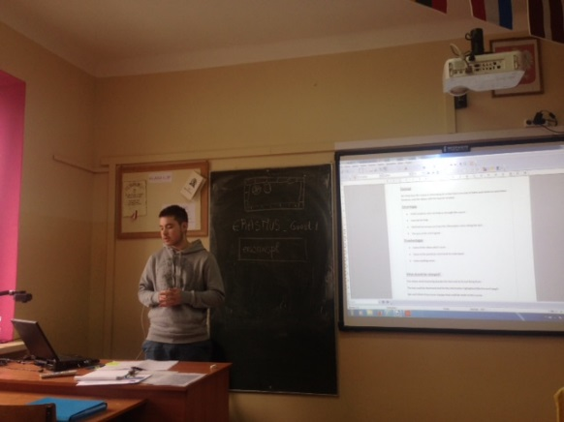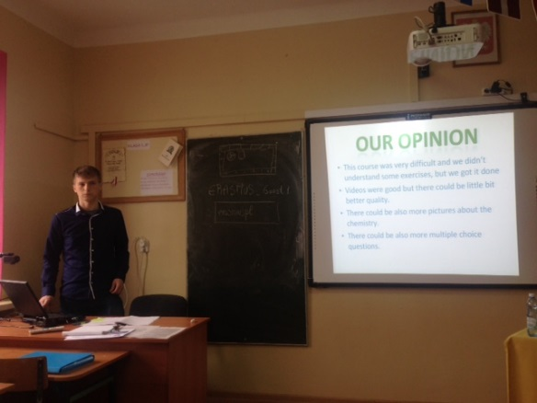

Some of the students that doing their presentations during steering meeting on the 11^{th and 12th} of April 2016

- Lunch and round tour at the school
Lunch with traditional Polish dishes and round tour by students in the afternoon.
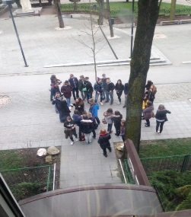Students outside the school on the 12th of April 2016

Day 2 12/4/16
- Further discussions in accordance to the updated operational plan and dissemination of the project and campaigning .
On the second day the Coordinator presented the dissemination Plan : how to prepare and work on Horizontal and vertical dissemination which are important for each partner country. The Coordinator discussed through the operational plan and steps within the dissemination process. For example horizontal refers to articles in local papers, local TV programs. After ending the courses in May the next step of dissemination will start in June with newsletters, on line paper to stake holders, and to teachers trying to get as many schools possible engaged in the project. Nicoletta , the Dissemination manager explained how to prepare Workshops which are to be held in each partner country as well as activities with other schools.

A discussion in regards to badges or/and certificates for students that have attended the courses was made and on how to achieve a Europass Certificate was brought up,
https://europass.cedefop.europa.eu/en/documents/european-skills-passport/europass-mobility. A Europass number is needed and it seems as if the europasses are created individually for each student. We need to get all the information about administration of Europass. Each partner is responsible to get this info from their home country and local agencies. Project numbers are needed to create the Europass certficates.

Further discussion was carried out on the challenge of getting students that lack in motivation or are about to drop out of school. Some very interesting aspects have been considered.

Doriana Papile
Transnational Coordinator

