(Code: 2014-1-IT02-KA201-003651_1)
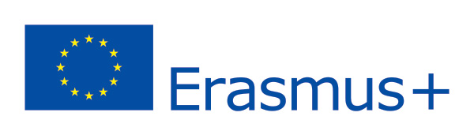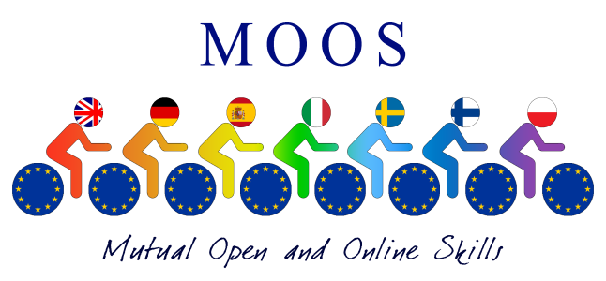
Final report on Roundtable held in Pescara March 2017
During the round table we had all Partner teachers and students give their feedback on the courses e speak about their experience.

Final Conference

The European Final Conference was held in Pescara (Italy) – 4th-5th May, 2017 and this second Multiplier event was held in the conference room of Europe Direct. All seven partners, stakeholders and authorities participated to The Final Transnational Meeting and Roundtable of MOOS. The aim of this roundtable was the sharing of Best practices in Open Education and the implementation of the first European Network of High Schools. During the round table the following issues were discussed:
The issue of Open education.
The evolution of OER in e-learning .
The cultural role of high-schools as e-learning innovation providers in European countries.
Results , reports and perspectives. (See files attached)
How we intend to keep the platform running and open to all European countries.
Discussion on Open Education Paper and the sustainability of its results.
What emerged from the best practices is the innovative approach of MOOS courses for High schools:
1. It has improved the use of ICT and the Open Educational Resources in the Curriculum of each partner high school by stimulating different and new ways of learning; In some of the high schools in the net students are awarded with credits after they have completed at least two online courses.
2. It has implemented new models and instruments for digital transnational classrooms with Common Curriculum in the 15 courses (common standard for competences, common models for validation of skills, assessment tests, etc.) and the development of digital lessons and educational resources in collaboration with students; Students involved in the project helped to build the online courses and tested them before they were released. This would never have happened if one had followed only normal school courses.
3. It has fostered the attainment of basic skills and the learning of key competences with digital tools in common (e.g., CLIL methodology) and in different languages (multilingualism); All 15 courses are in English and follow the CLIL methodology. Some foreign partners-Teachers found difficulties in explaining their online subject in another foreign tongue. This turned out to be very challenging.
4. It has extended the accessibility of high school courses, especially for disadvantaged students (all courses are now open and on line), as factors to prevent and to reduce early school leaving or as a compensation instrument; See Open Education Paper attached.
5. It has enhanced the quality of teaching with the strengthening of teacher competences in the use of OER (specific training for teachers has been involved in the project) and the change-and-challenge-based profile of new teachers ( the teacher as tutor and learning mediator). Before the project started most teachers did not know how to upload lessons ,or add a script to a video or create the activities. After the training courses and ICT training laboratories a new world of technology was inspirational for both students and teachers taking part in the MOOS project.
This project includes several objectives and priorities of Erasmus+ Program and E&T 2020 such as the enhancement of ICT in teaching and learning, the development of basic skills (digital skills, multilingualism, etc.) using an innovative approach, the improvement of the professional profile of the teaching profession.
The MOOS Platform will remain accessible and adaptable to all the High Schools that participate in Transnational Network OEHS (Open Education High School).
We will continue publicising the project in order to enhance added value for institutions through leaflets, newsletters and dissemination in local schools and updating courses and MOOS portal.

Project Coordinator Doriana Papile

