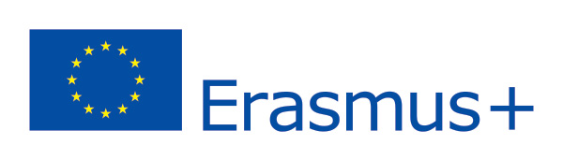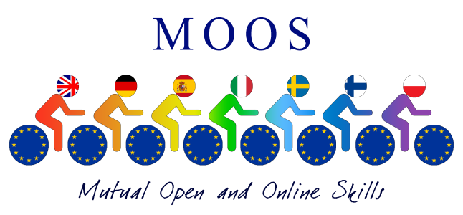
Project MOOS - Mutual Open and Online Skills
(Code: 2014-1-IT02-KA201-003651_1)

REPORT of 1st Steering Meeting in Pescara
26th and 27th November, 2014.

Our first steering meeting was held in Pescara on the 26th and 27th November, 2014. The principle aim of this meeting was to Start up of the Erasmus Plus and inform all partners on the planning of all the activities to carry out during the mobilities of 2014-2017.
At 9:00 a warm welcome was given by the Headmaster Mr.Di Iorio in the Assembly Hall at School (Liceo Galileo Galilei Via Vespucci) , soon followed by The Project Coordinator Doriana Papile who read out the Agenda of the day.
At 10:00 all seven partners started introducing their schools showing the videos or Power Point presentations they had brought moreover all students introduced themselves and presented their school to the others.
After the coffee break the Project Coordinator presented the Operational Plan of the Project and explained the different roles and work to be done. Power Point Slides were illustrated on Open Education Resources followed by a Question Time in which all participants shared some ideas and questions on the new Project MOOS.
After the Lunch Break, The Steering Group discussed on The Creation of an Open Educational Digital Platform followed by a discussion. Workpackage 2. All partners decided to test two platforms: Edx and Canvas for a short period of time and then decide which would be the best for the Moos Platform.
From 3:30 to 4:30 pm, The steering Group discussed on an Experimentation of a Common Curriculum and chose the disciplinary areas to create the MOOS courses on.
From 4:30 to 500 pm - Presentation on Validation and on different ways of dissemination followed by a group discussion.
After 5:30 short walk around the City of Pescara.
The whole activity was attended by Project managers, Teachers and Students involved in the MOOS Project.
Day 2
This activity was attended only by project managers and teachers, the students were involved in group activities with Italian students.
During the morning activities the Steering Group read out the administrative and financial agreement and management. Explanation was giving on the documents to be produced. Some Time was also spent on the Project start up activities such as the Transnational Meetings and Training Activities and on the importance to use the E-Twinning Portal.
From 11 to 11:30 Steering Group discussed on various issues .Steering Group Meeting ended at 12:30 then after lunch all Partners departed.
While The steering meeting was being held all students , together with our Evaluation Manager Fabrizia Floro and Dissemination Manager Nicoletta De Thomasis ,visited the Local Museum Casa di Gabriele D’Annunzio and the Maritime Museum.

Doriana Papile
Transnational Coordinator

