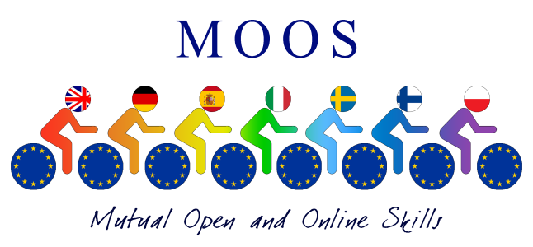

Moos Trailer is a presentation of the 15 MOOS Courses . The trailer was prepared by students and teachers during Mobility in Finland:

https://youtu.be/dTmFMRldEy8

