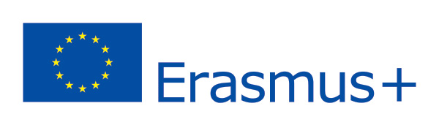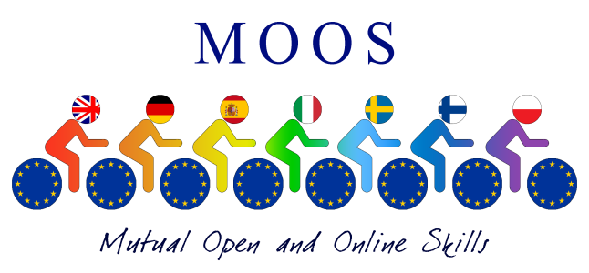
BEST PRACTICES IN SPAIN.
THE FOLLOWING LINK SHOWS HOW THE SPANISH DELEGATES HAVE DISSEMINATED THE PROJECT DURING THE THIRD YEAR OF REALIZATION.THE VIDEO AND PPT WERE PRESENTED AT THE FINAL ROUNDTABLE HELD IN MAY 2017 IN PESCARA.
LINK:
https://youtu.be/zppNdp3suJk

